Planning a Report about the session of graphology

Reporter: Sara Cordella

The present work aims at sharing the results of the information gathered during the session on forensic graphology by the expert M.s. Sara Cordella, a forensic graphologists herself. It is part of what goes under the name of “percorsi per le competenzetrasversali e per l’orientamento”, a learning session considered compulsory in the curriculum of Italian state secondary schools.

The idea is to offer students an occasion to experiment what some job positions may be like so that the experience may work as guidance.

The professional profile of a graphologists is strictly connected with the interpretation of the way one writes. It follows that a graphologist should be provided with documents, letters or other texts that represent the object of their interpretative work.

The first section of the work will be devoted to illustrating the instructions and guidelines provided during the learning sessions. Indeed they are related to the different writing aspects of the text under discussion.

The second section will offer some illustrating examples from different sources.

The third section will record our efforts: we translated the guidelines into an interpretative practise to show the competences we have gained.

The conclusion will discuss the process work and its results commenting on points of strength and weakness.

GUIDELINES

**MARGIN**

Everybody writes taking up the sheet’s surface variously. Dividing the sheet of paper vertically, it is possible to distinguish between different ways of taking up the space. The blank sheet of paper represents the world that surrounds the individual. Each part of the sheet of paper is given an aspect of personality.

Examples:

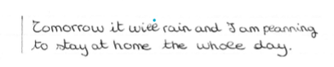

1. **Example:**

As you can clearly see the left margin is quite absent. It implies that the writer can be introverted, shy, attached to his/her family (especially with his/her mother) and bound to past experiences.

1. **Example:**

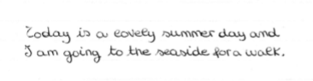

From the image it is possible to notice that right margin is very small. This feature means that the writer can be friendly, sociable, attached to his/her father and open to new experiences. In addition, the writer can have great planning abilities

1. **Example:**

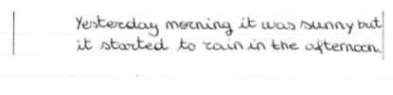

As you can notice, the left margin is reduced as the text moves forward. it follows that the writer on the one hand seeks some more independence, but on the other hand he is still a little bit scared and he needs reliable points of reference.

**Summing up:**

1. In the left zone are located the mother dimension, the family attitude and past references.
2. In the right zone are located  the father dimension, social skills, planning abilities, , future references
3. When one starts writing far from the edge and then comes nearer shows that he wants some independence but he is a little scared.

**STACCATA**

This graphological sign consists of big spaces between words.

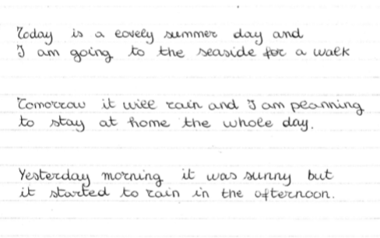

As you can clearly see from the examples the words are detached. This sign shows that the writer may have exceptional ability to analyse but doesn’t have an attitude for summarizing.

**SLANTED**

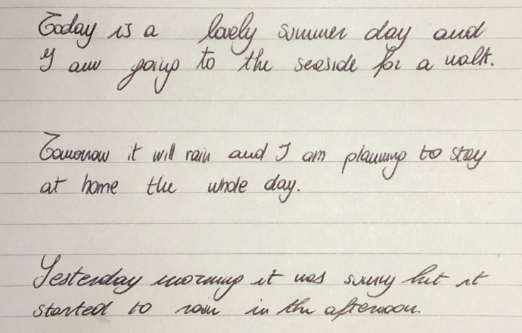

It can be seen from the examples the handwrites turns to the right, that means the writer shows an emotional attitude. When the handwriting is too slanted the sign is typical of jealous and specious emotional attitude.

Third section:

Sofia Dri:

After the attendance to the graphology session, I will now put into practice my take aways, analysing the writing of one of my classmates. In doing so, I will consider the guidelines provided by the graphologist Ms Sara Cordella.

The first aspect I am going to focus on is the margin: The writer started writing without leaving any space from the left margin. This could represent the tendency of the writer to be introverted, shy, attached to her family, especially with her mother and bound to past experiences.

Secondly, I noticed the tendency to write with high pipe especially in the letters f, t and h. This means that the writer present the typical features of creativity and fantasy.

Moreover, it is interesting to notice that the letters present a curve line. This is indicative about the ability to adapt and to host, typical in women.

In addition, the writing presents some pressure, synonymous of energy.

Another important element to consider is the calibre: the writing I am analysing is particularly small. This feature implies that the writer may be introverted and have great summary skills.

Another characteristic what can be easily noticed is the big space between words. This sign is called staccata and means that the writer may have a better capacity of summary than of the analysis one. These spaces indicate the time between thoughts and actions.

Looking at the sheet of paper, it is possible to observe a generally tendency to determination: this feature is drawn by the fact the reading keeps the line straight.

To sum up, it is possible to say that the writer may be a woman with great capacities of summary; she may be determined, very attached to her family and may presents creativity skill.

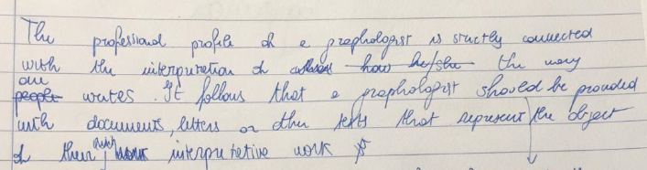

Alice Santoro

The purpose of the present text is to translate the previous guidelines into an interpretative practise. The text will discuss about the different aspects of Nada Hafiane’s following writing extract. 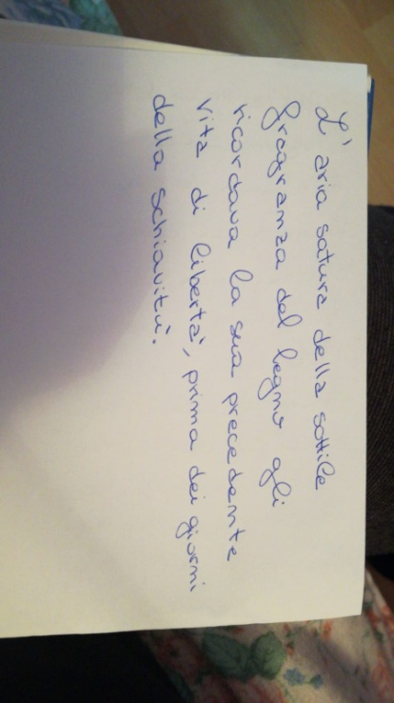First of all, considering how she took up the space, I can notice that the left margin is normal and rigid. This aspect shows detail regarding order and harmony in the relationship with the mother. On the other hand the right margin first moves closer to the border but then decreases and so shows caution to approach the father’s dimension.

Going on, considering bars and tails, they are both quite long, suggesting concreteness as well as a vivid immagination.

You can aso notice that the writing is more curved than angular, showing openness and unselfishness rather than self-preservation.

Considering the large sized handwriting, it shows exageraion and hyperbole. This feature is typical of people who like to declaim and act.

In addition, there isn’t much space between letters, that means the person usually keeps things for herself.

On the other hand you can notice spacing between words, showing exceptional abilities to analyze but a bat attitude for summarizing.

Furthermore some letters are backed against. This feature is tipycal of those who do much but has little returns.

Going on, considerng the direction of the line, it is quite stable showing firmness and ability to go straight to the point.

Moreover you can notice a backward slant, showing diffidence towards people and focus on the past events.

Last but not least you can notice the bars tobe parallel each other. This feature is typical of people who need to be methodical and organized. They are at the same time reliable and they hardly tire theirselves out when doing things.